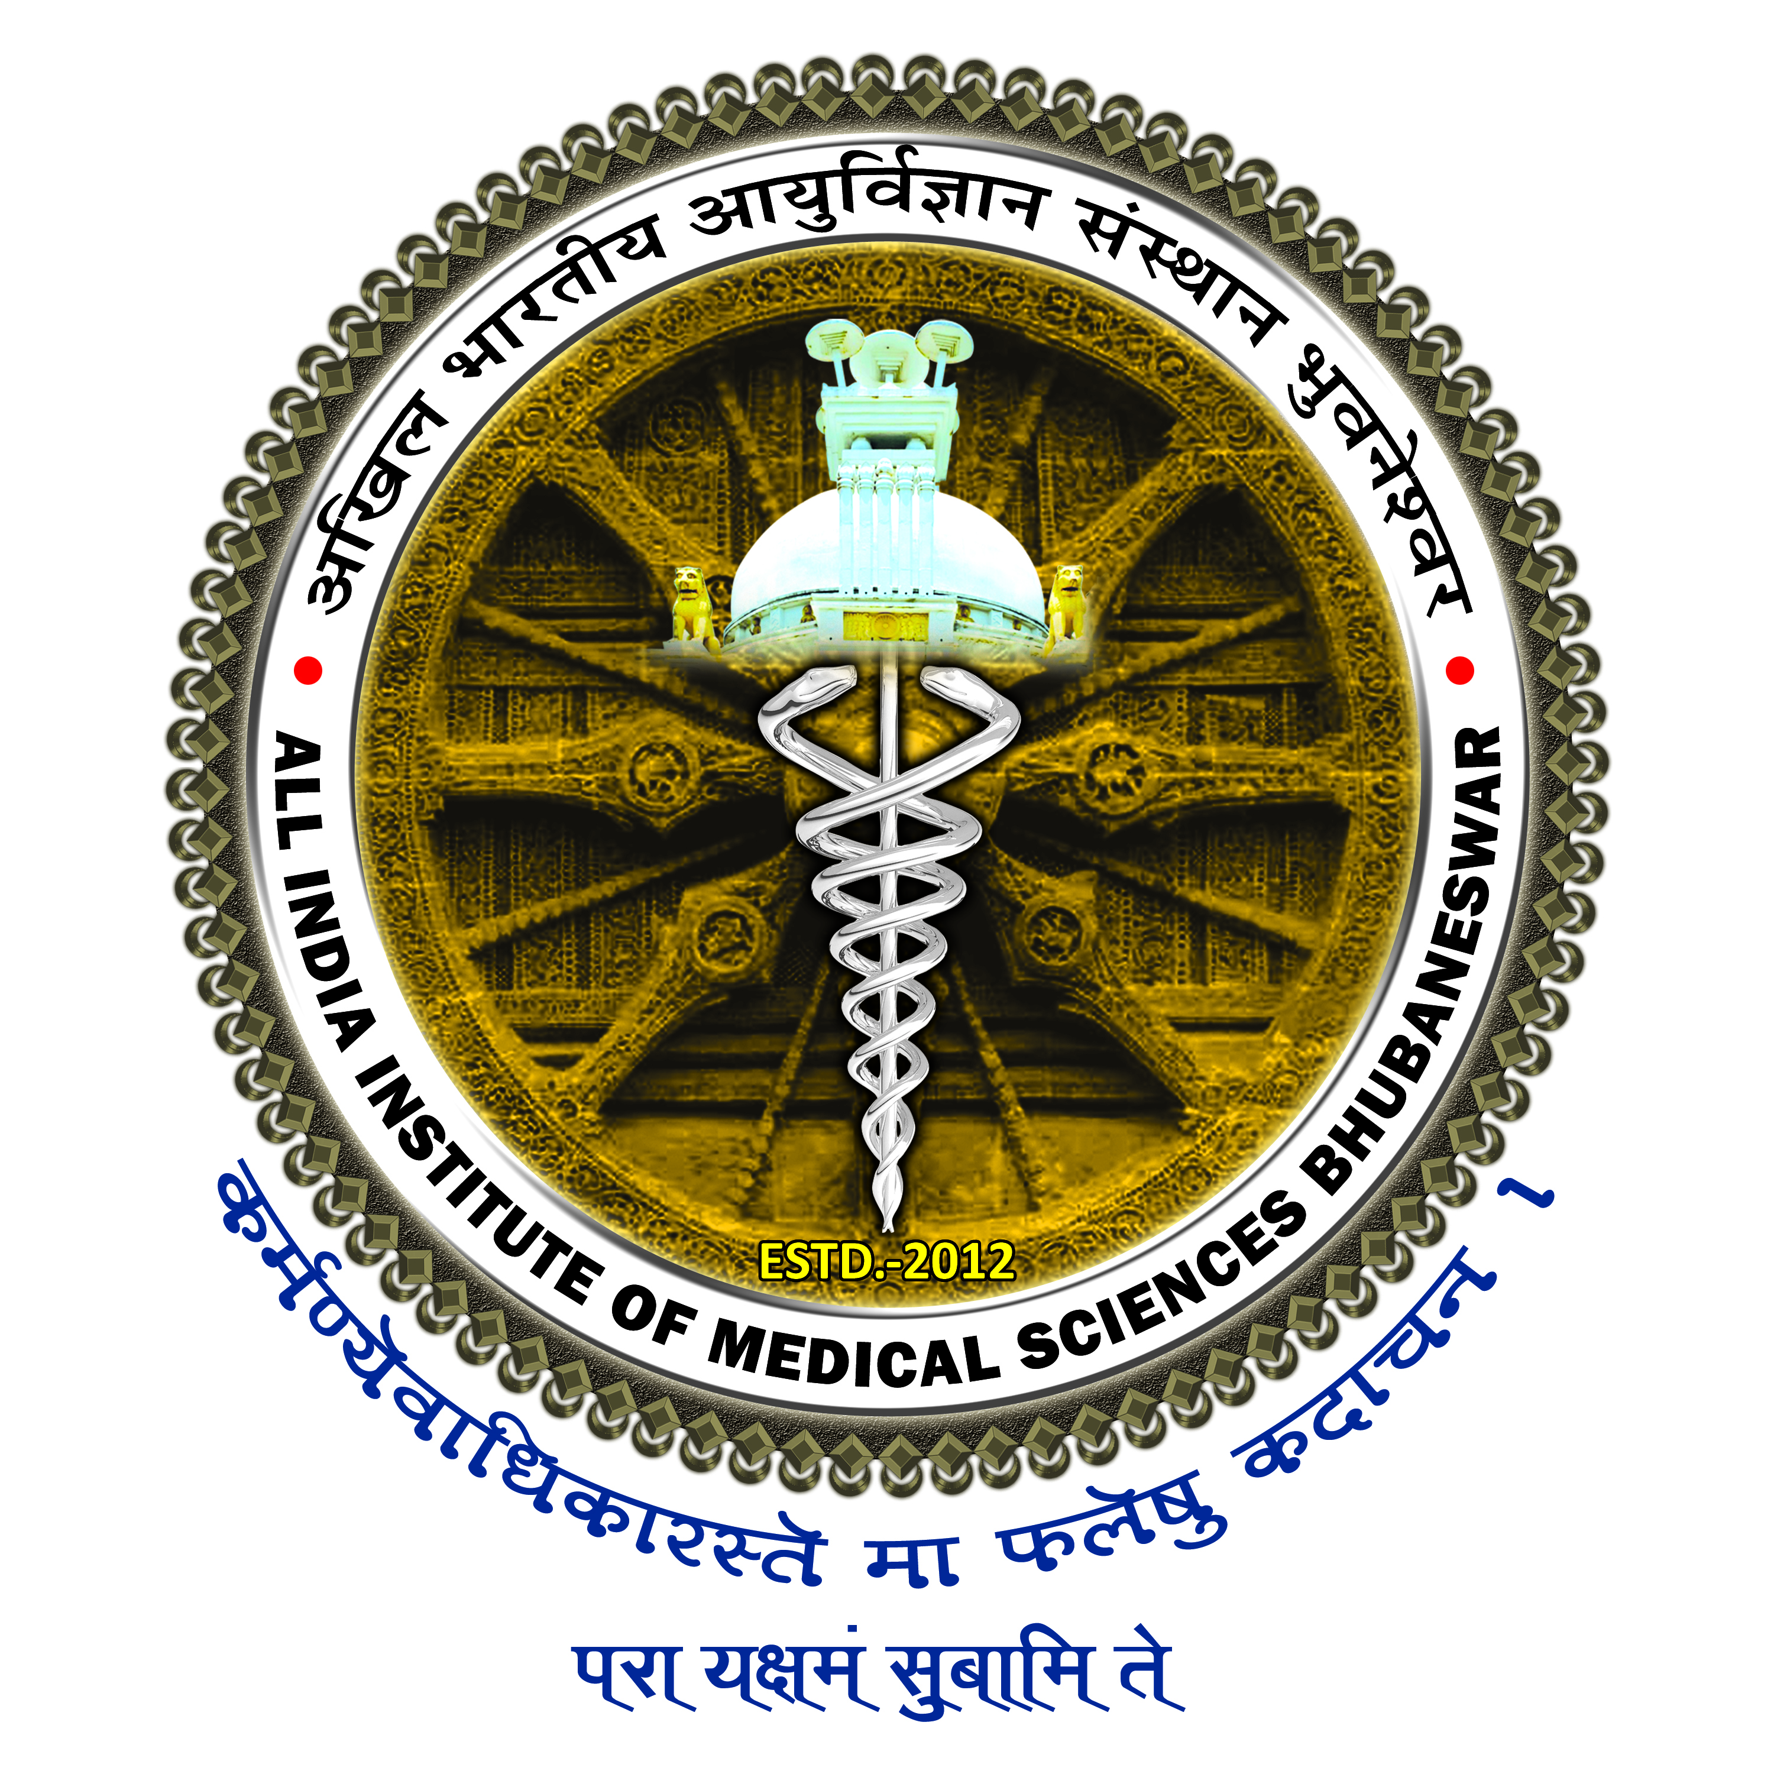

अखिल भारतीय आयुर्विज्ञान संस्थान, भुवनेश्वर
All India Institute of Medical Sciences, Bhubaneswar
(A Statutory Body under aegis of Ministry of H & F.W., Govt. of India)
सिजुआ, डाक-: डूमुडुमा, भुवनेश्वर – 751019
Sijua, Post: Dumuduma, Bhubaneswar- 751019

APPLICATION FORM FOR SEEKING PERMISSION TO ATTEND SCIENTIFIC MEETING/CONFERENCE/SYMPOSIUM/SEMINAR/WORKSHOP/SHORT-TERM TRAINING OR COURSE OR PROGRAMME WITHIN INDIA
01 | Name of applicant with Designation & Department
02 | Date of appointment as faculty member
03 | Name of the event (in full)
04 | City & State where the proposed event is to be held
05 | Duration of the proposed event with dates
06 | Name of the organizer of the event (Organizing Secretary)
07 | Status of the organizing institution. (Private/Govt./Govt. funded/scientific association/ non-profit non-govt. organization/others. In case of others, specify).
08 | State the facilities in terms of air-fare, boarding, lodging and remuneration/honorarium etc. being provided by the organizer/host institution or any other institution/agency. Attach documentary evidence in support of the same.
09 | In case from AIIMS, Bhubaneswar clearly mention the Registration Fee Amount / TA / DA etc.
10 | Whether the applicant is attending the entire period of event. If not, indicate the actual date(s) of participation
11 | Intended date of departure from Headquarters (H.Q.) & from venue and joining back to the duty | Date of departure from H.Q | Date of departure from venue of event | Date of joining back duty.
12 | Categories of participation:  Presenting scientific paper / to chair/co-chair a scientific session / to deliver lecture as invited speaker or faculty in workshop/invited to participate the event / invited for availing of training in a specified course or programme offered by universities? Please specify and attach documentary evidence.

Contd…Page 2
Page - 2
13 | Furnish the following documents (Mandatory):
 | (a) Acceptance letter of scientific paper for presentation duly signed by the concerned authority of organizer OR Invitation letter to participate as a delegate in the event OR lecture/talk/live workshop and/or chairing/co-chairing of session.
 | (b) Copy of abstract of scientific paper
 | (c) Brochure/Programme of the event
14 | On attending the above event, how it will be benefitted / utilised at AIIMS Bhubaneswar on larger public interest :
15 | Name, dates and destination of last event attended
16 | Whether departure, joining and participation reports submitted in r/o last academic event attended
17 | Name the faculty who will look after the duties during the applicant’s absence from headquarters for the purpose.
Certified that the information furnished above by me are true and correct to the best of my knowledge and nothing has been concealed. I also undertake that my participation in the afore-mentioned event is in accordance with the existing guidelines of the Institute.

Date : Signature of the applicant
__________________________________________________________________________________

FOR HEAD OF THE CONCERNED DEPARTMENT USE ONLY
- In case more than one faculty member(s) is attending the proposed event from the Department, the following information may be furnished: -
Sl.No. | Name & designation of the faculty member | Actual duration of absence for the purpose from the Institute
However, the above faculty members have to submit their separate application in the prescribed proforma for considering them for permission.

- Faculty members who will be available in the concerned Department/Centre during the period of absence
of the applicant and as at part “A” of above, from the headquarters
Sl.No. | Name & designation of the faculty member
(While forwarding the application(s) of faculty member(s) for such purpose, the Chief of the Centre/Head of the Department should ensure the availability of 50% of faculty members on duty during the period of their absence from headquarter).

Recommendations of Head of the Department
with signature, date and Office stamp

All India Institute of Medical Sciences, Bhubaneswar
(A statutory body under aegis of Ministry of Health and Family Welfare, Govt of India)

Sijua, Post: Dumuduma, Bhubaneswar - 751 019

ACADEMIC LEAVE

01 | Name
02 | Designation
03 | Department
04 | Purpose for which leave is required
05 | Leave Duration | From: ____________ To _____________ (No of days) _____
06 | Sundays and Holidays, if any, proposed to be prefixed/ suffixed to leave. If yes, specify the date(s)
07 | Whether permission for leave the station is required (applicable for within India only) | Yes/No
08 | Date of Return from leave
09 | Address during leave
10 | Phone/Mobile No.
11 | Mail Id
12 | Charge Handed Over to

___________________________________________________

(Name & Signature of Faculty/ SR Who is Taking Over charge)

_____________________
Date: Signature of Applicant

Remarks and Recommendations of the Head of the Department.
(It is certified that at-least 50% faculty members will be on duty in the Department during the aforesaid period and the services and functions of the Department will not suffer in any manner.

Leave as proposed above is recommended/not recommended (if not recommended, then the give the reason)

